Hillcrest, North Fremantle
Anne Brake

Hillcrest was built by Francis and Emma Pearse in 1902 as a family home. Francis was one of five surviving sons of William Silas Pearse, who arrived in Western Australia on the Egyptian in February 1830 as a labourer. Francis built on his father’s success as a business man and when he died in 1919, Francis was one of the wealthiest men in the state.

Recognised as one of the Merchant Princes of Fremantle, Pearse’s extensive home was built on the corner of Harvest Road and Helen (now Turton) Street, one of the highest points in North Fremantle, and had views to the Swan River and the Indian Ocean. The 2 storey stucco and tile residence was a very late example of the Victorian Italianate style and was considered one of the most substantial and handsome residences in North Fremantle. Its elevated position, the tower and 3 remaining Norfolk Island pines, one of which was decorated at Christmas through the 1950s, 60 and 70s, ensured Hillcrest remained a prominent Fremantle landmark across the twentieth century.

After Francis’ death, Emma found a letter in his favourite bible which spoke of his wish to donate Hillcrest to charity. She followed his wishes giving the home to the Salvation Army in 1921. A maternity hospital for unmarried mothers, including midwifery training, was opened in 1922 and operated at Hillcrest until 1974, except for a short time between 1942-44 when it housed US Army personnel. As well as unmarried mothers, many women had their babies here; some of you reading this may have born there.

The introduction of the contraceptive pill and the decrease in the stigma of unmarried mothers saw a decline in the need for the maternity hospital and it closed in 1974. The buildings were converted to a Nursing Home for the Aged which opened in 1980.

Over time the beautiful home had been modified and extended with 2 building campaigns in 1934 and 1958. The land on the southern side of the home was sold to the government for the construction of the new North Fremantle Primary School in the early 1960s. Regis Aged Care bought the site in 2013.

The redevelopment of the building into a 21st century aged care facility has seen extensive conservation and restoration work to Hillcrest with many features still intact including the beautiful main staircase, fireplaces and various decorative elements. Various accretions and additions were removed or demolished. Sadly, the original home is now hidden by extensive modern additions and is only partially visible from Turton St. The original home houses a number of services for the residents including lounge and seating areas, a café, a private dining room which can be booked for special occasions, a small theatre for movies, a hair dresser and the like. Specialist areas such as kitchens and laundries, as well as the various levels of accommodation, dining rooms and recreation areas are included in the new sections.

While mostly hidden from the street, residents and their guests and staff can enjoy Hillcrest including having a cup of coffee and light refreshment from the now restored verandahs taking in views across the river to East Fremantle.

Hillcrest was classified by the National Trust in 1980 and was entered into the Register of the National Estate in 1982. In 2000 it was included in the Municipal Inventory for Fremantle and put on the State Register of Heritage Places in 2006. Its redevelopment is subject to a heritage agreement which was lodged in 2016. Hillcrest’s redevelopment was a finalist in the 2017 WA Heritage Awards in the Conservation or Adaptive Reuse category.

Historic images:
Nurses and babies at Hillcrest, 1922. Izzy Orloff, SLWA BA 1059/148-150
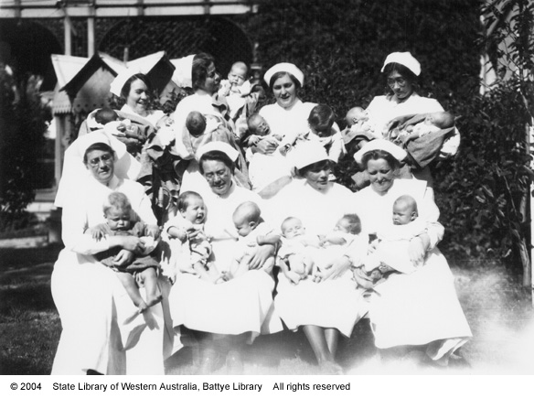
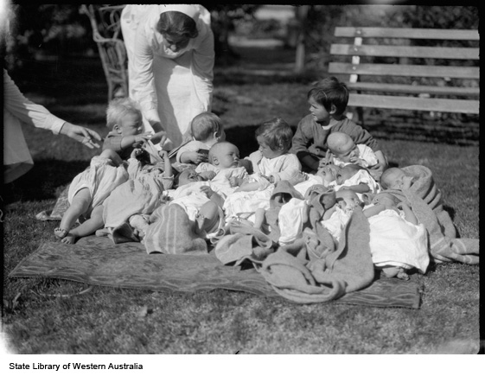

Hillcrest from Turton St. Undated/unsourced image on the Regis site sign (2020)

